**Bootcamp 4**

1. Created all the resources

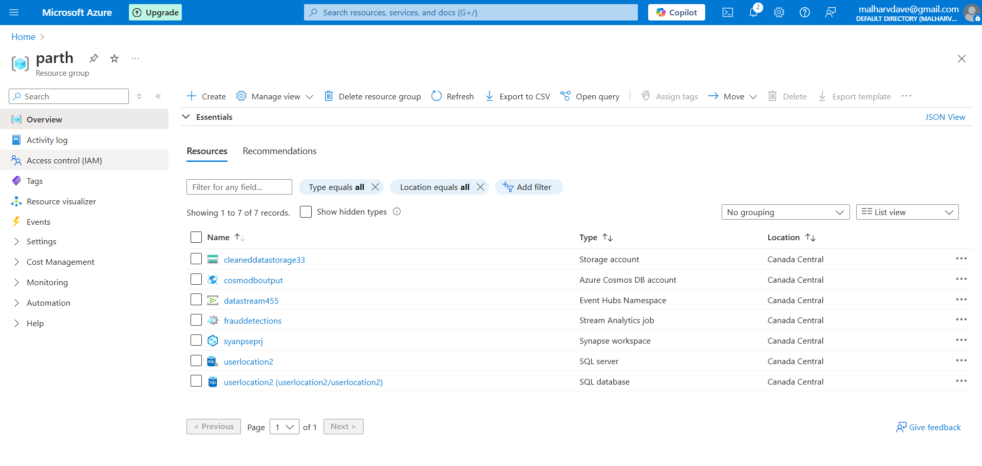

2. Created SQL table for UserLocations

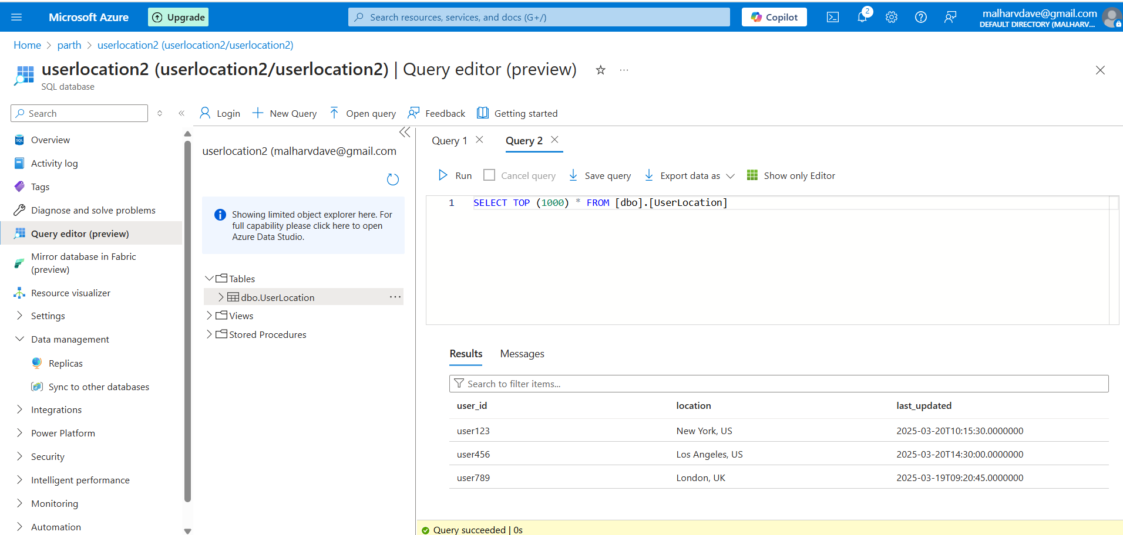

3.Created Eventhub, stream analytics, send the data from eventhub into stream analytics

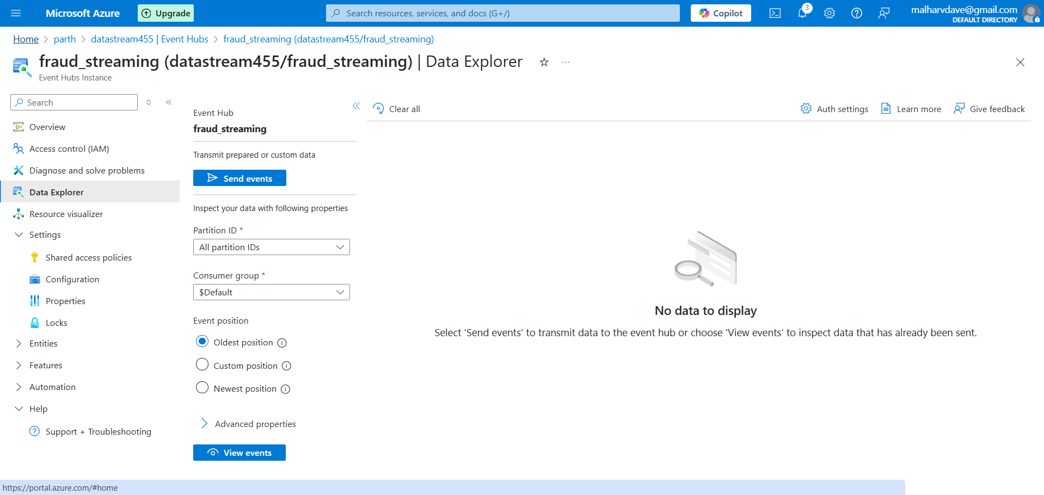

4. Input sources

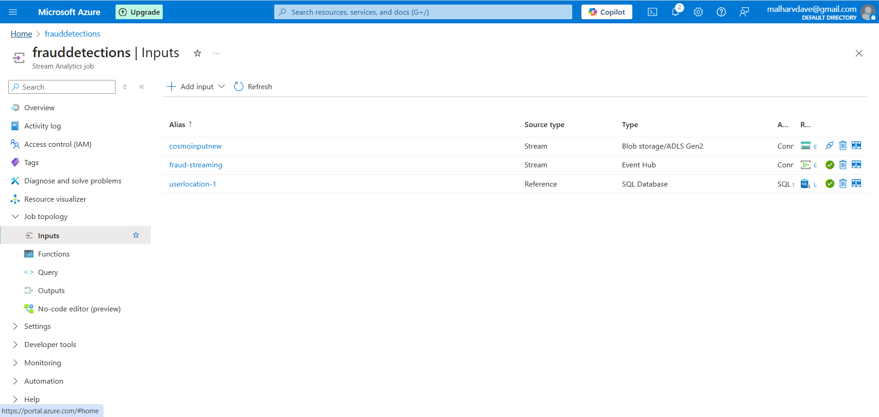

5. Query to Filter Data

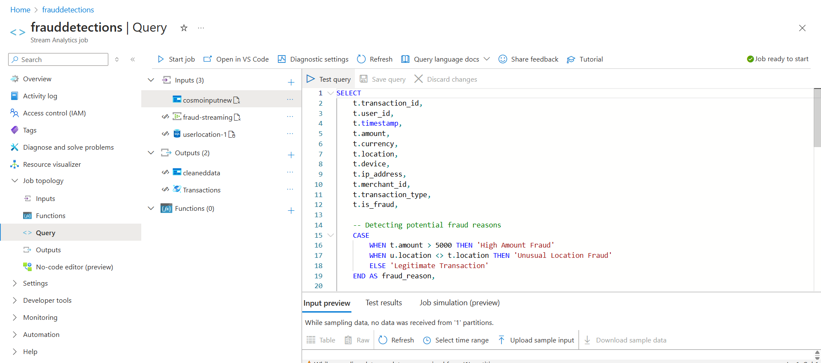

6. Output sources

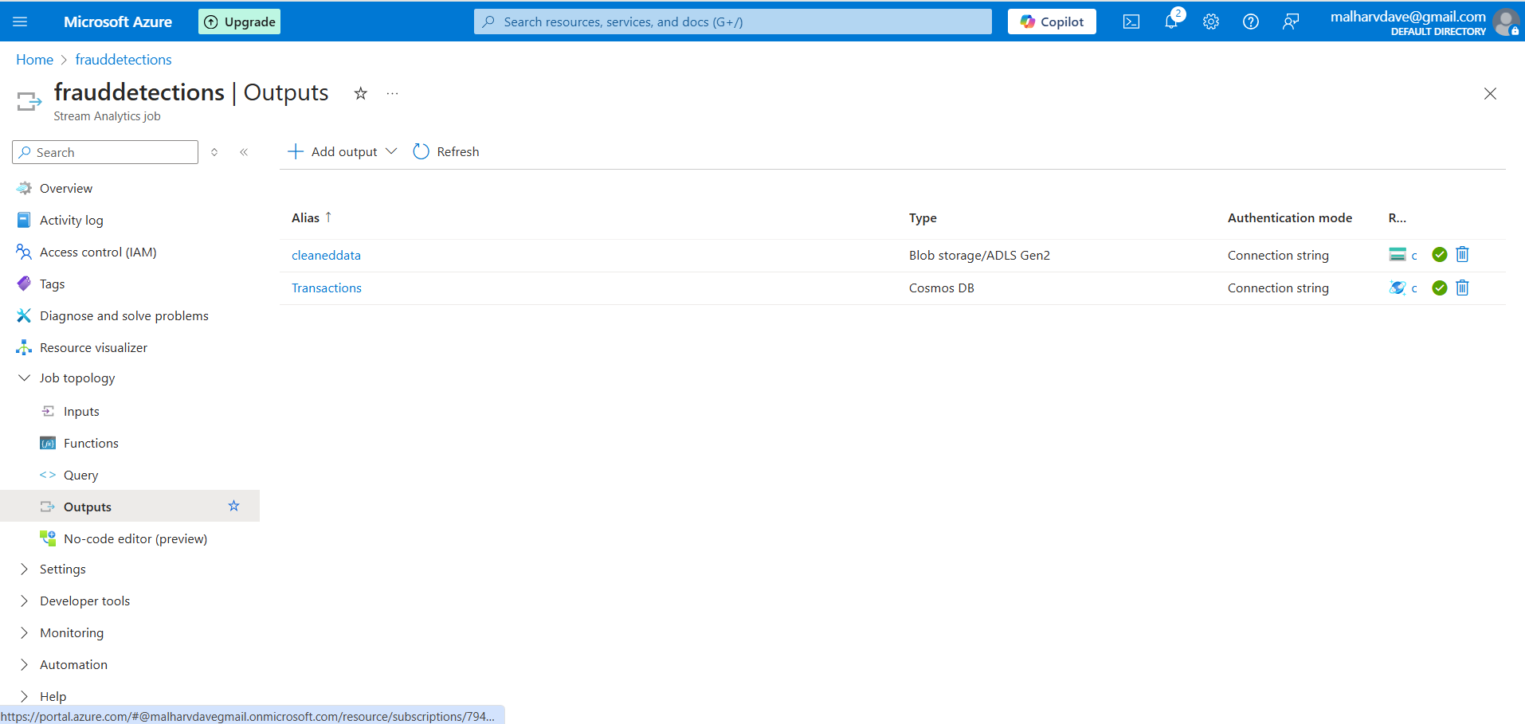

7. After the running the job and query successfully>data stored into cleanedata container as Parquet files

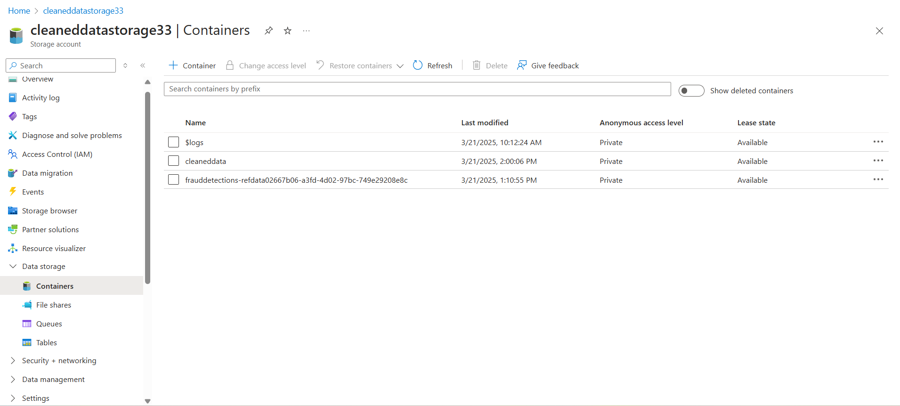

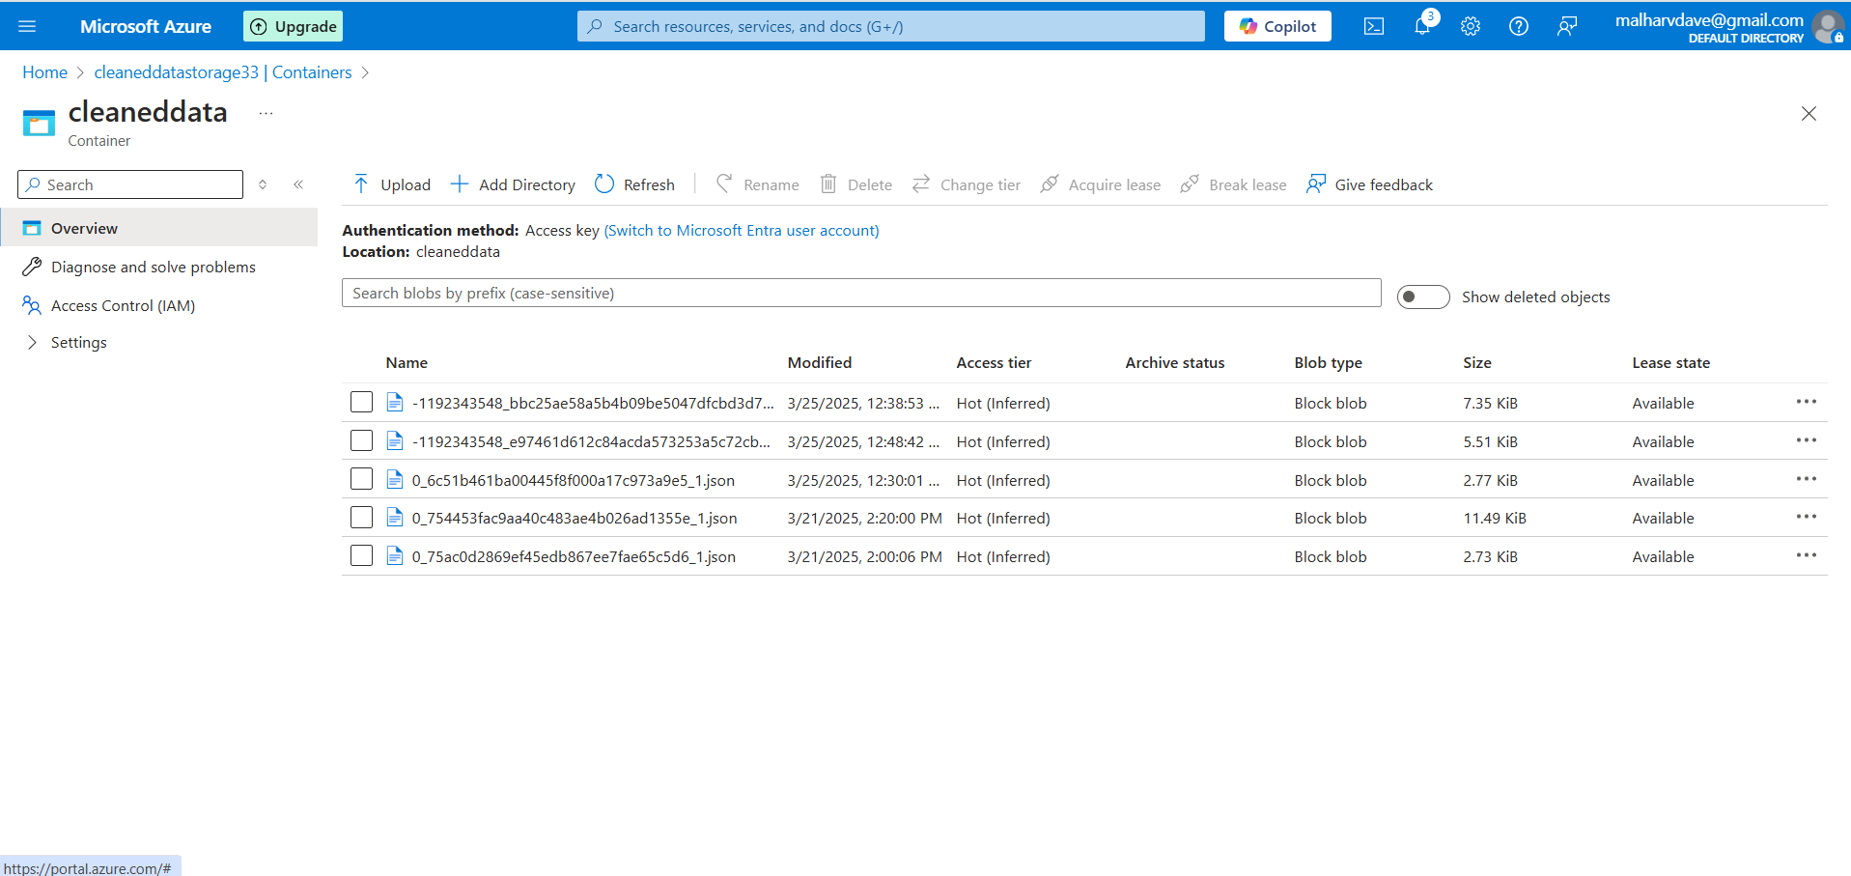

8. For Unique Transactions send data to cosmodb created Transaction Database and table

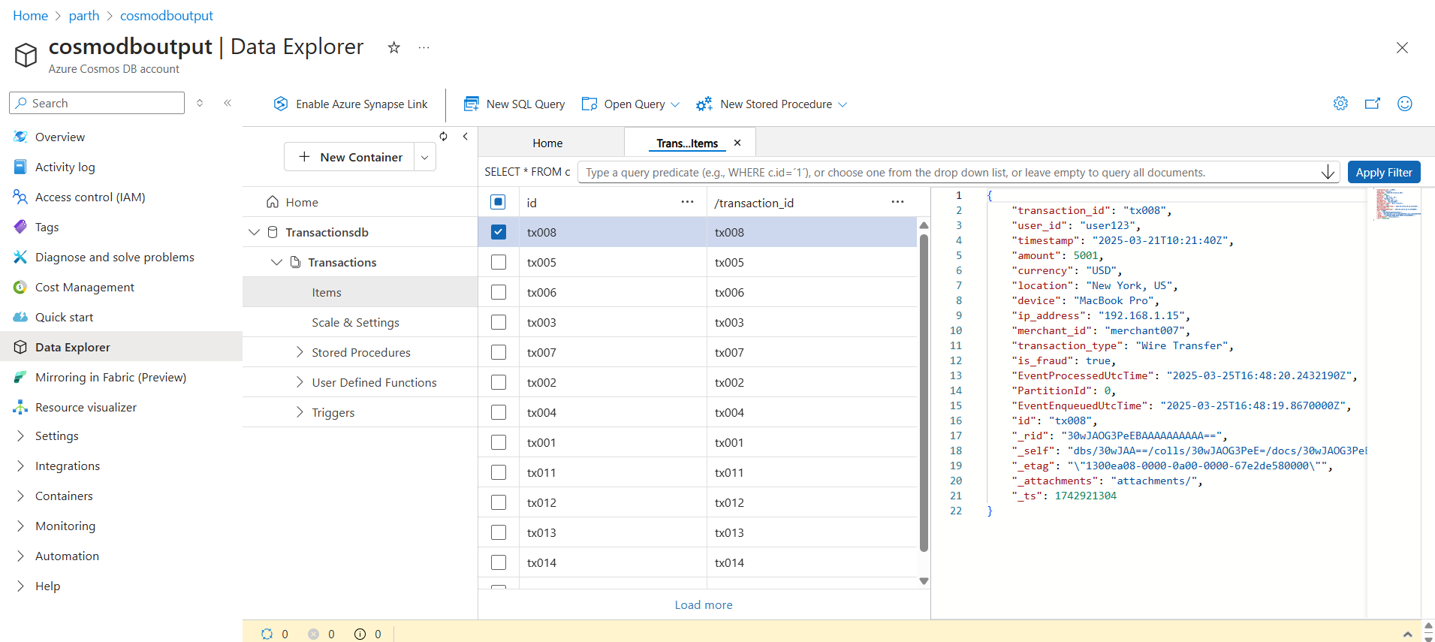

9. Took the storage account file into synapse and read the file.

